**1 no answer**

**1st part**

A recurrence relation is an equation that recursively defines a sequence where the next term is a function of the previous terms (Expressing FnFn as some combination of FiFi with i<ni<n).

**Example** − Fibonacci series − Fn=Fn−1+Fn−2Fn=Fn−1+Fn−2, Tower of Hanoi − Fn=2Fn−1+1

Limitations of recurrence relations:

1. It gives a boundary value and an equation for the general value in terms of earlier ones.
2. The recurrence allows us to compute T(n) for any n we like. But it becomes complex when n is large.
3. It takes too long time to solve any problem using recurrence relation when the value of n is large.

**2nd part**

There are 4 possible ways or methods to solve recurrence relation. Those methods are:

* **Iterative method:** This method converts the recurrence into a summation and then relies on a technique for bounding summations to solve the recurrence.
* Substitution method: For this method we guess a bound and then use mathematical induction to prove our guess correct.
* recursion-tree method: It converts the recurrence into a tree whose nodes  
  represent the costs incurred at various levels of the recursion. We use techniques  
  for bounding summations to solve the recurrence.
* master method: It provides bounds for recurrences of the form.

**Example**

Now, we will find the solution of Tower of Hanoi using iterative method. Here, representing a “closed form” of T(n) which will let us compute it quickly, even for large n. This “closed form” is basically a mathematical expression or formula. This mathematical expression is known as solution of  
recursive relation.

T(n)=2T(n-1)+1  
=2[2T(n-2)+1]+1  
=22T(n-2)+2+1  
=22[2T(n-3)+1]+2+1  
=23T(n-3)+22+2+1  
.  
.  
=1+2+22+23T(n-3)  
=20+21+22+23T(n-3)  
=20+21+22+…..+2n-1T[n-(n-1)]  
=20+21+22+…..+2n-1T(1)  
=20+21+22+…..+2n-1x1 [as moving one disk requires minimum 1 move, T(1)=1]  
=20+21+22+…..+2n-1  
= 1(1-2n)/1-2 [geometric series, a (1-rn)/(1-r)]  
= 2n-1  
The solution for the recursive relation of tower of hanoi is 2n-1.

**2 No ans**

**Part1**

**Summation notation:** Often mathematical formulae require the addition of many variables Summation or sigma notation. It is a convenient and simple form of shorthand used to give a concise expression for a sum of the values of a variable.

Now, deriving an expression of summation notation for the “Tower of Hanoi” problem using summation factor.

The Tower of Hanoi recurrence is a case in point:

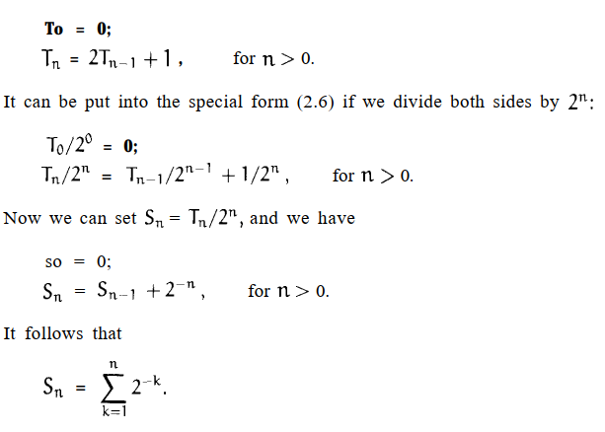

We know that there’s an intimate relation between sums and recurrences.  
The sum:

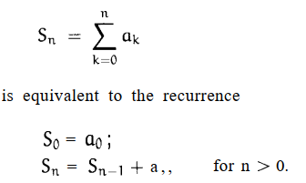

So, it is the expression of summation notation for “Tower of Hanoi”.

Therefore, we can evaluate sums in closed form.

So the recurrence relation for “Tower of Hanoi” is:

To =O;T, = 2Tn-1 +l , for n > 0.

Recurrence relation and sums are equivalent to each other. (proved)